Clinical and Genetic Epidemiology
Winter School 2017
Lecturers

Prof. Konstantin Strauch

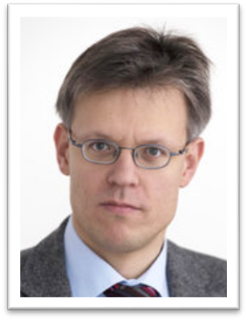 | Director of Institute of Genetic Epidemiology (Helmholtz Zentrum München)
Institute of Genetic Epidemiology (Helmholtz Zentrum München)
Chair of Genetic Epidemiology, IBE (LMU Munich)
 | http://www.helmholtz-muenchen.de/ige/das-institut/mitarbeiterinnen/mitarbeiterinnen/ma/321/index.html
 | strauch@helmholtz-muenchen.de
Topics:
Genetic Epidemiology – Basics of Genetics
Cancer Genomics
Personalized Medicine and Study Designs

Prof. Ulrich Mansmann

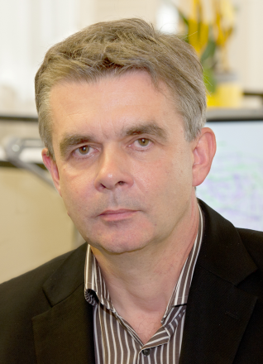 | Director of Institute of Medical Informatics, Biometry and Epidemiology (IBE), Chair Biometry and Bioinformatics
 | Institute of Medical Informatics, Biometry and Epidemiology (LMU Munich)
 | http://www.ibe.med.uni-muenchen.de/organisation/mitarbeiter/010_direktorat/mansmann/index.html
 | mansmann@ibe.med.uni-muenchen.de
Topics:
Intra- and inter-tumor heterogeneity
Statistics
Clinical Studies and Translational Medicine

Dr. Christian Gieger

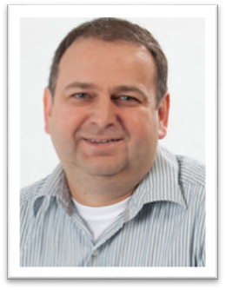 | Head of AME and Head of 'MOMICA' Research Group
 | Research Unit Molecular Epidemiology (AME), Institute of Epidemiology II (Helmholtz Zentrum München)
 | https://www.helmholtz-muenchen.de/ame/research/research-groups/index.html
 | christian.gieger@helmholtz-muenchen.de
Topic:
Metabolomics

Dr. Gabi Kastenmüller

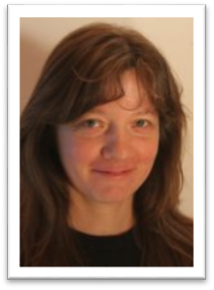 | Chemist, Computer Scientist, Head of Metabolomics Group
 | Institute of Bioinformatics and Systems Biology (Helmholtz Zentrum München)
 | https://www.helmholtz-muenchen.de/en/ibis/institute/groups/metabolomics/staff/staff/ma/655/index.html
 | g.kastenmueller@helmholtz-muenchen.de
Topic:
Metabolomics

Dr. Anne Quante

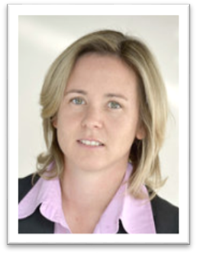 | Head of Team “Cancer Epidemiology – Individualized Risk Assessment”
 | Institute of Genetic Epidemiology (Helmholtz Zentrum München), IBE (LMU Munich)
 | http://www.helmholtz-muenchen.de/ige/das-institut/mitarbeiterinnen/mitarbeiterinnen/ma/3723/index.html
 | anne.quante@helmholtz-muenchen.de
Topics:
Prediction Models for Cancer
Direct-to-consumer Genetic Testing

Dr. Christine Fischer

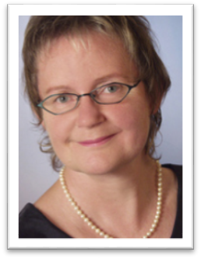 | Head of Genetic Epidemiology/Biostatistics Group
 | Institute of Human Genetics (University Hospital Heidelberg)
 | http://www.klinikum.uni-heidelberg.de/Fischer-Ch.5429.0.html
 | christine.fischer@med.uni-heidelberg.de
Topic:
Prediction Models for Cancer

Dr. Larissa Schwarzkopf

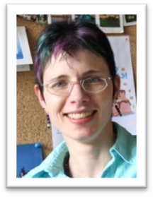 | Head of Economics and Management of Lung Diseases Group
 | Institute of Health Economics and Health Care Management (Helmholtz Zentrum München)
 | https://www.helmholtz-muenchen.de/igm/das-institut/ueber-uns/mitarbeiter/mitarbeiter/ma/137/index.html
 | l.schwarzkopf@helmholtz-muenchen.de
Topic:
Health Economics and Ethics

Aarif Mohamed Nazeer Batcha, M.Sc.

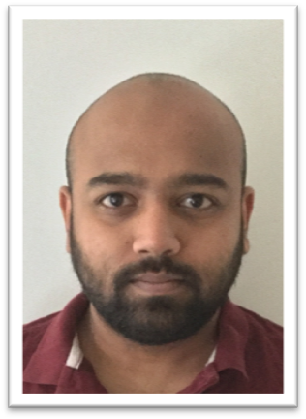 | Biotechnologist, Epidemiologist
 | Institute of Medical Informatics, Biometry and Epidemiology (LMU München)
 | http://www.ibe.med.uni-muenchen.de/organisation/mitarbeiter/070_drittmittel/nazeer-batcha/index.html
 | nazeer@ibe.med.uni-muenchen.de
Topics:
An Introduction to Next-Generation Sequencing
NGS data analysis using Galaxy: A hands-on course

Dr. Martina Müller-Nurasyid

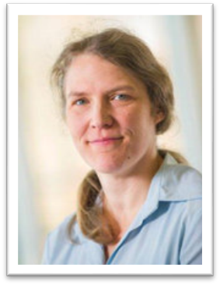 | Head of Team “Cardiovascular Genetics and Population Structures”
 | Institute of Genetic Epidemiology (Helmholtz Zentrum München), Department of Medicine I, Klinikum Grosshadern (LMU München)
 | http://www.helmholtz-muenchen.de/ige/das-institut/mitarbeiterinnen/mitarbeiterinnen/ma/3722/Dr.-M%C3%BCller-Nurasyid/index.html
 | martina.mueller@helmholtz-muenchen.de
Topic:
Basics of Genetics
Genetic Association Analysis with ECG Parameters

Prof. Stefan Kääb

Rhythmology, Department of Medicine I
Klinikum Grosshadern (LMU Munich), Deutsches Zentrum für Herz-Kreislauf-Forschung (DZHK), Munich Heart Alliance
http://www.klinikum.uni-muenchen.de/Medizinische-Klinik-und-Poliklinik-I/de/team/leitende_oberaerzte/KaabStefan/index.html
stefan.kaab@med.uni-muenchen.de
Topic:
Personalised Medicine in Cardiology - Rhythmology as Example

Prof. Anne-Laure Boulesteix

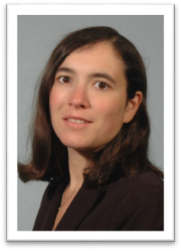 | Head of Computational Molecular Medicine Group
 | Institute of Medical Informatics, Biostatistics and Epidemiology (LMU München)
 | http://www.ibe.med.uni-muenchen.de/organisation/mitarbeiter/020_professuren/boulesteix/eng.html
 | boulesteix@ibe.med.uni-muenchen.de
Topic:
Statistics for High Dimensional Data

Prof. Ingolf Cascorbi

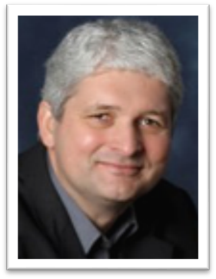 | Director of Institute of Clinical and Experimental Pharmacology
 | Christian Albrechts University Kiel
 | http://www.uksh.de/pharmacology-kiel/
 | cascorbi@pharmakologie.uni-kiel.de
Topics:
Pharmacogenomics

Brigitte Strahwald

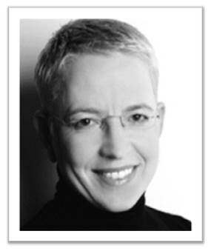 | Health Communication Expert, cognomedic Managing Partner
 | cognomedic GmbH
 | http://www.cognomedic.de/Home.html
 | strahwald@cognomedic.de
Topic:
Direct-to-consumer genetic testing

Prof. Hans-Werner Mewes

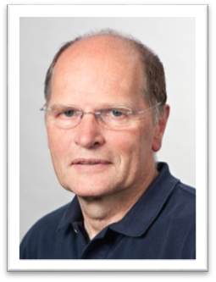
Chair of Genome Oriented Bioinformatics (Life Science Center Weihenstephan, Technical University of Munich)
Institute of Bioinformatics and
Systems Biology (Helmholtz Zentrum München)
http://bioinformatik.wzw.tum.de/index.php?id=70
w.mewes@helmholtz-muenchen.de
Topics:
Complexity and Causality in Personalized Medicine
Data Integration and Knowledge Exploration

